**

**LEARNING ACTIVITY SHEET**

**SPECIAL PROGRAM IN ICT 7**

**OFFICE PRODUCTIVITY-MICROSOFT EXCEL**

*Third Quarter, Week 6*

**FORMAT WORKSHEETS**

**Background Information for Learners**

Numbers in Excel can assume many different formats such as date, time, percentage or even decimals. It is necessary to format the cell and its content because of the way how MS Excel stores information especially with numbers. With this, it is significant to format the fields in your spreadsheet accordingly.

**Formatting Cells and cell contents**

**Formatting Numbers**

To format the appearance of numbers in a cell, just follow these steps:

1. Select a cell or range of cells
2. Click the right button of the mouse then select Format Cells from the shortcut menu
3. The format cells Dialog box will pop – up
4. 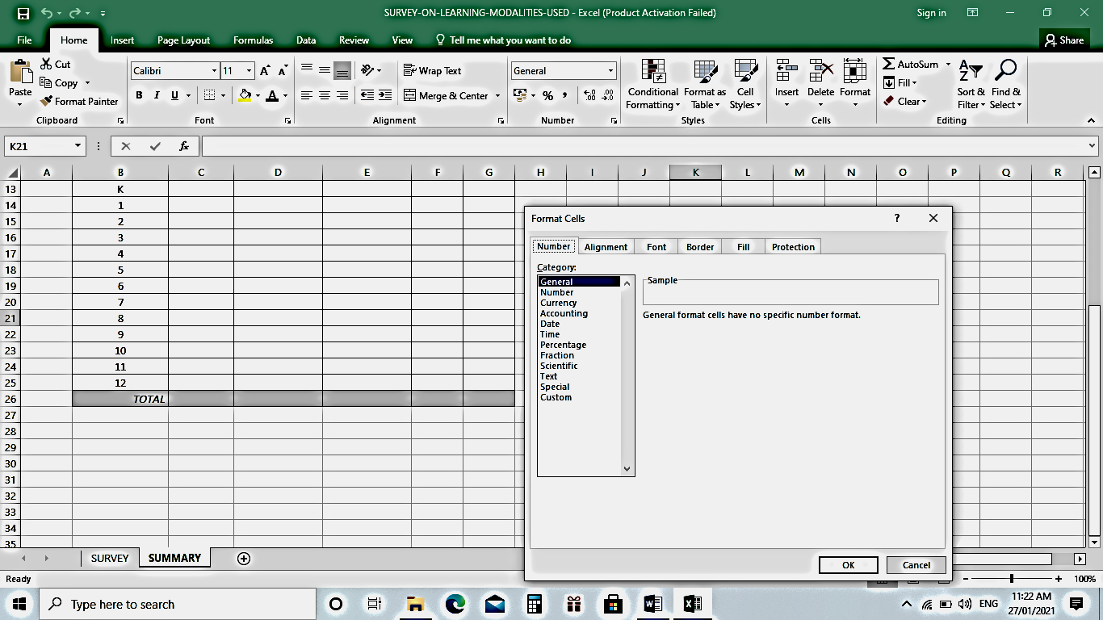Click the Number tab
5. Click **Number** in the category drop-down list.
6. 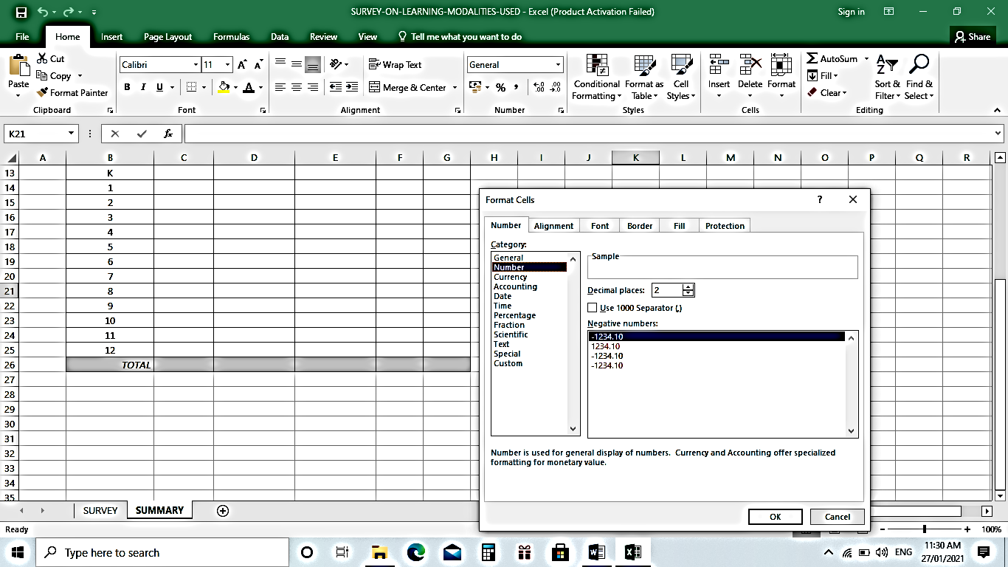Use the decimal places scroll bar to select the

number of decimal places to be displayed.

Ex. 2 would show 26.50 and 3 would show 26.500

1. Click **Use 1000 Separator** box if you want commas (1,000) injected in the number.
2. Use **Negative numbers** drop-down list to indicate how numbers less than zero are to be shown.
3. Click **OK** button

**Formatting Date in the Format Cells Dialog Box**

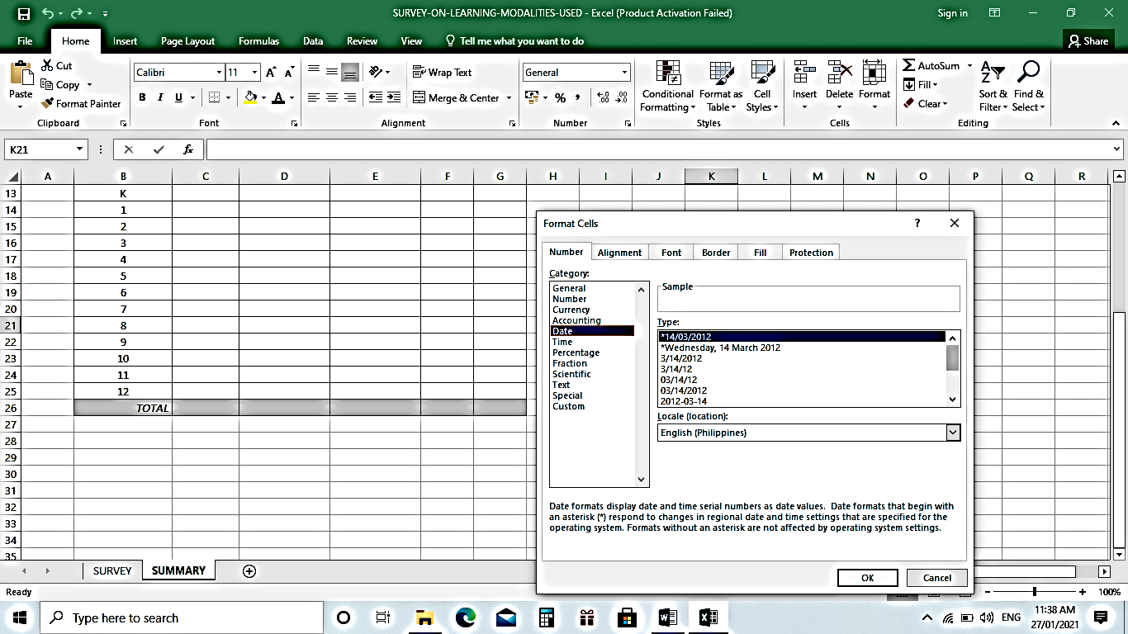

**Formatting Time in the Format Cells Dialog Box**

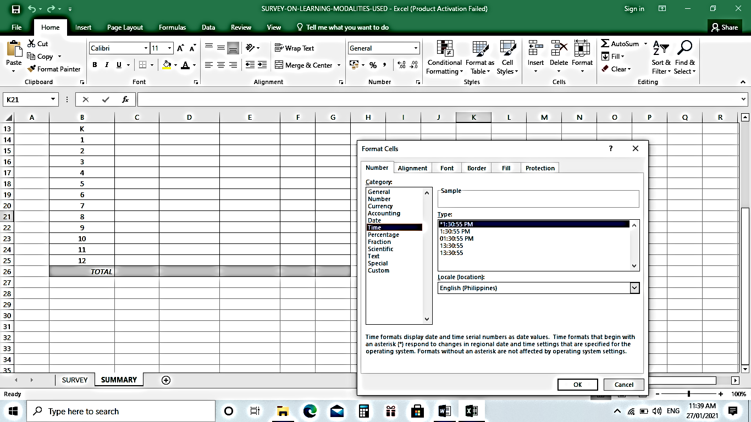

**Formatting Percentage in the Format Cells Dialog Box**

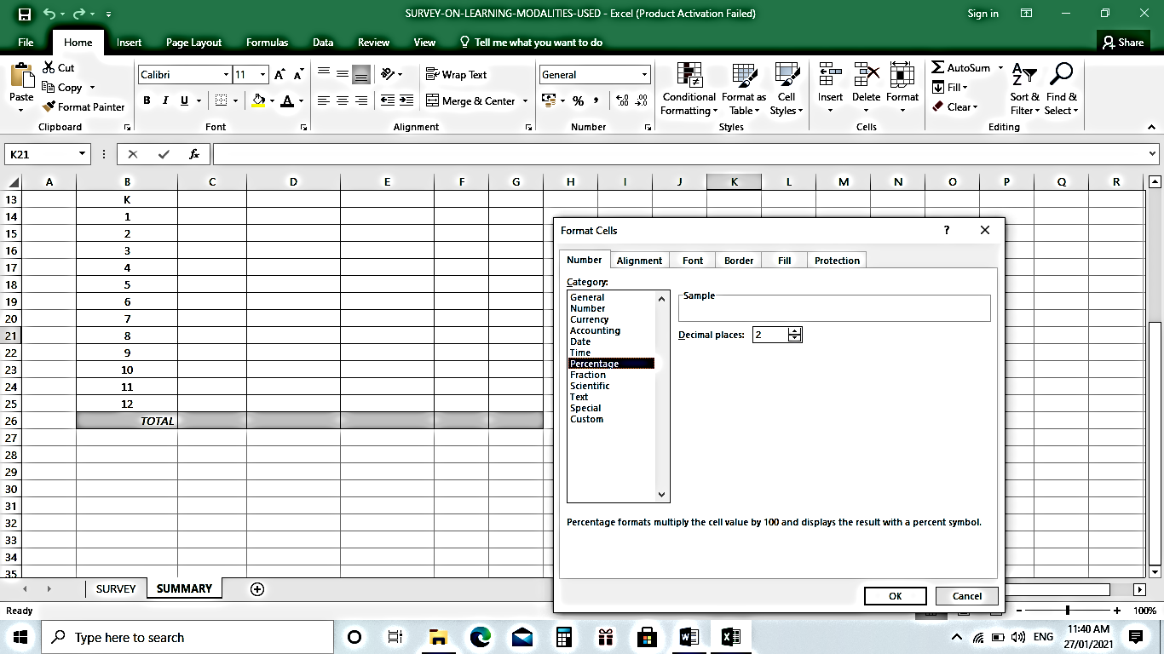

**Changing the Font and Font size**

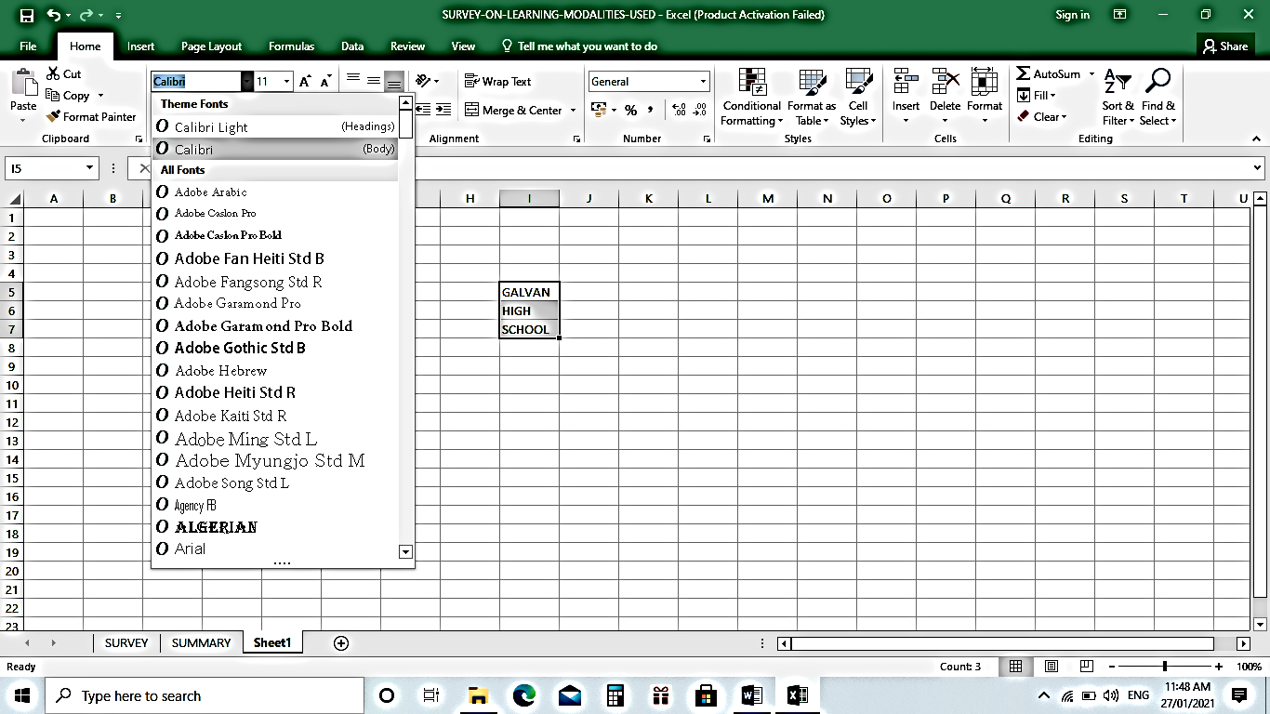To change the font style of data inserted in a cell, select the cell or range of cells then choose the desired font from the **Home** tab.

Highlighted text

Font styles to choose from

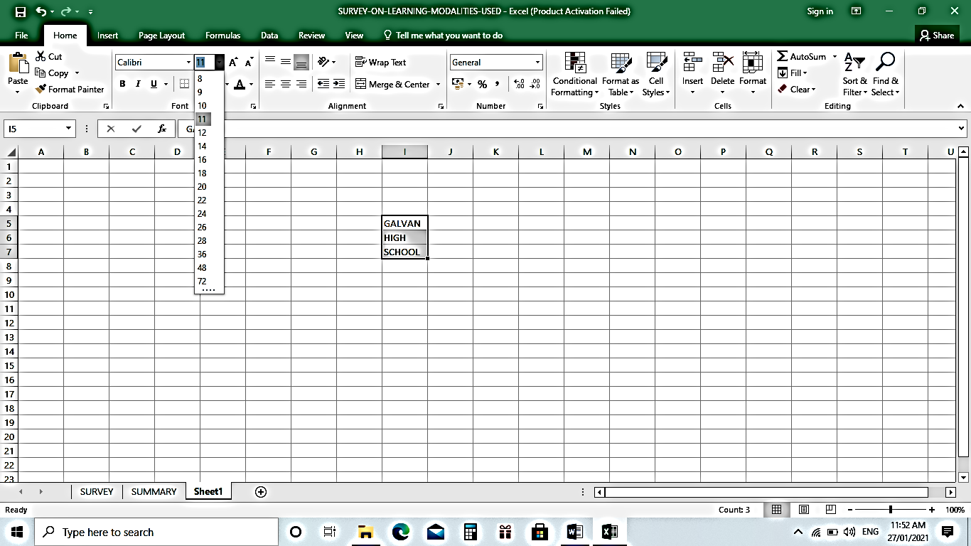To change the font size of data inserted in a cell, select the cell or range of cells then choose the desired font size from the **Home** menu in the **Ribbon.** You can also directly input the desired font size once it is highlighted or selected.

Font size to choose from

Input desired font size here

Highlighted text

**Changing the Font color and Fill color**

To change the font color of data inserted in a cell, select the cell or range of cells then choose the desired color from Font Color choices under the **Home** menu in the **Ribbon.**

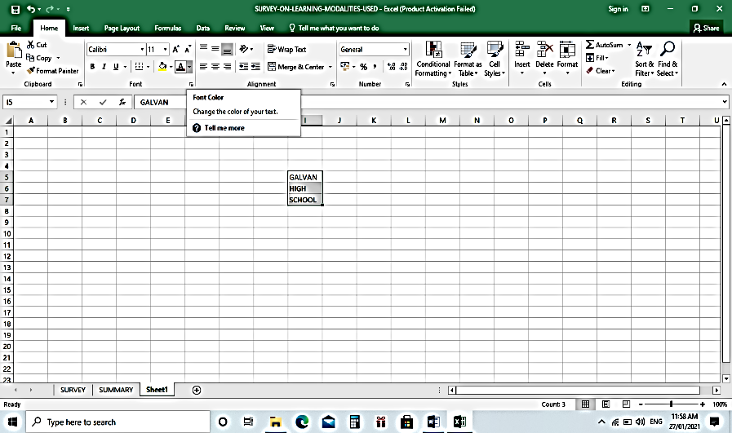

Font Color

To change the Fill color of a cell, select the cell or range of cells then choose the desired color to fill from Fill Color choices under the **Home** menu in the **Ribbon.**

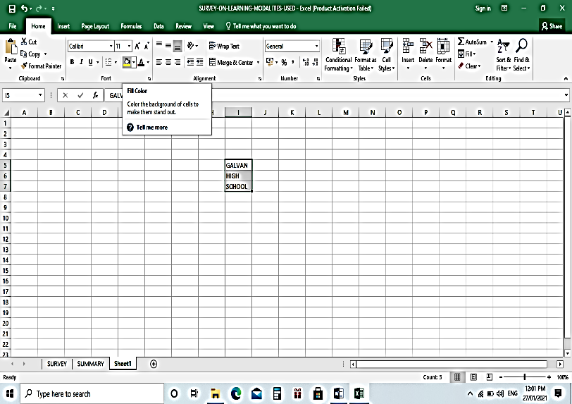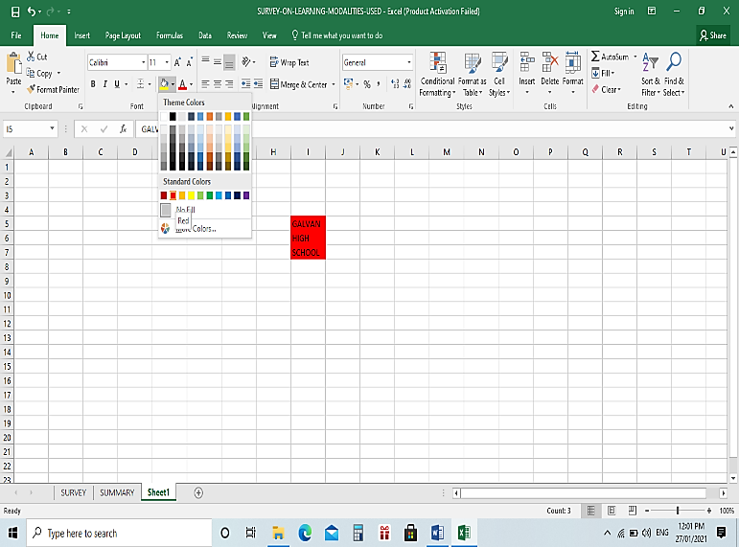

Fill Color

Colors to choose from

Sample Fill Color

**Adding Cell Border**

**To change the border of a cell**

1. Select the cell or range of cells then choose the desired border to apply from the **Border** found under the **Menu tab**

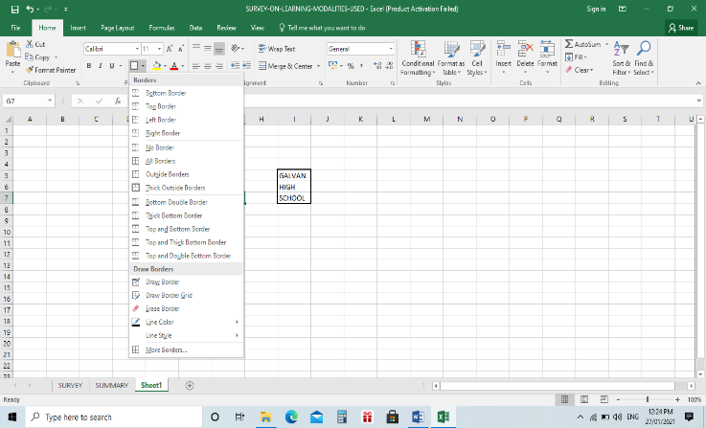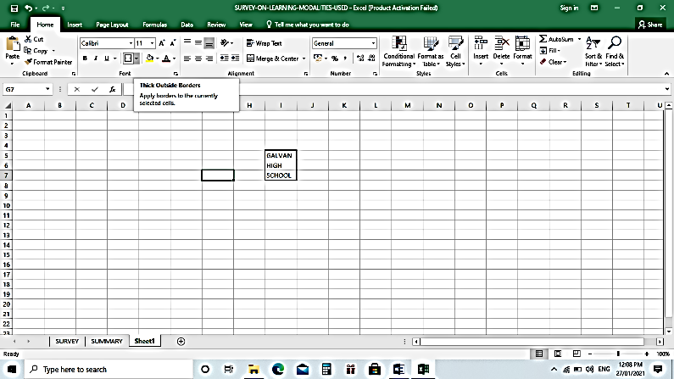

Border

Sample Border

Borders to choose from

1. Another way to add cell border is to select the cell or range of cells, click the right button of the mouse and select Format Cells on the submenu.

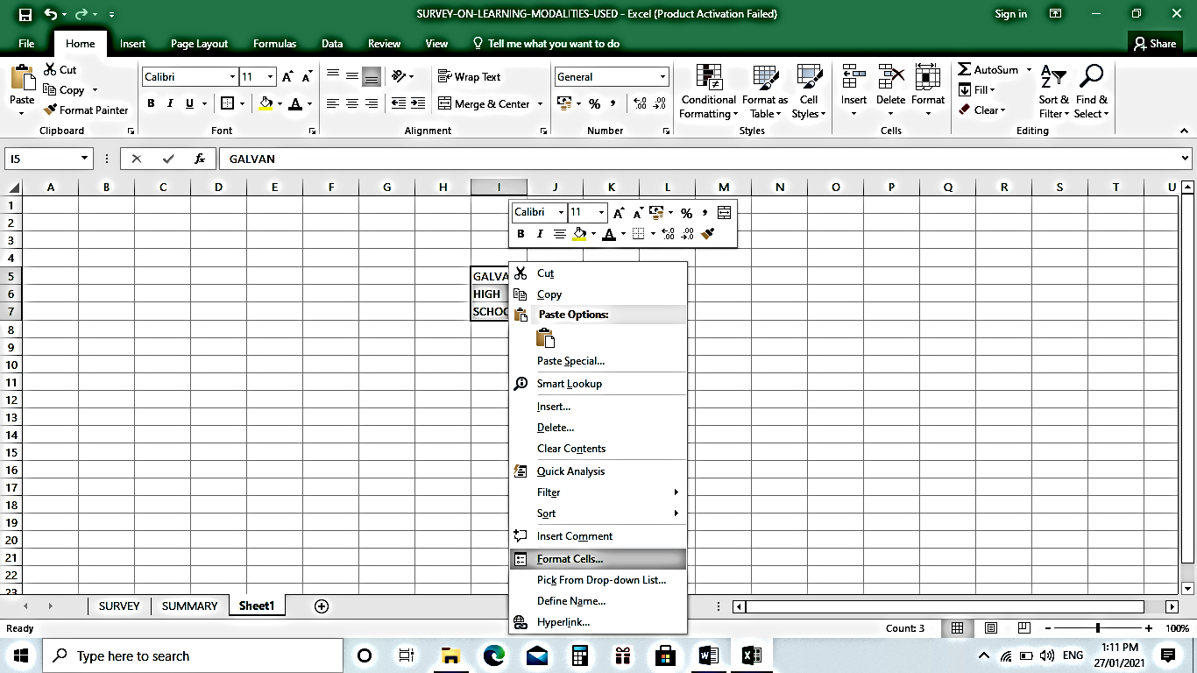

Format Cells

1. The format cells Dialog box will pop – up
2. Click the Border tab and select the type of border you want to apply on the selected cells

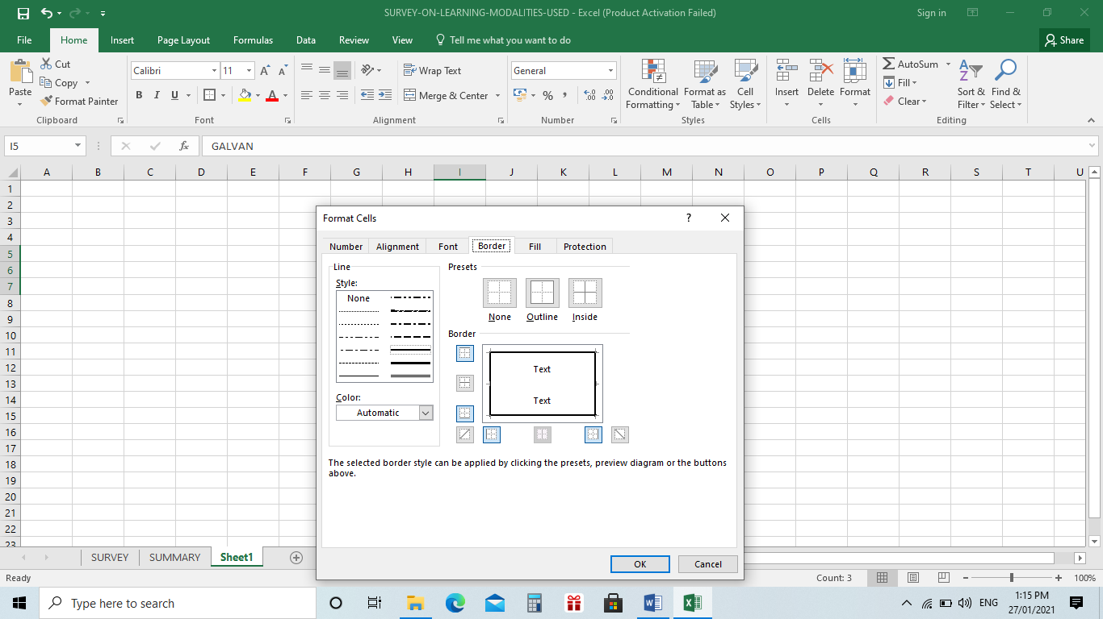

Border tab

Type of border to choose from

Part of the cell you want to apply border

**Positioning Cell Contents**

Text by default is left – aligned and Numbers by default is right – aligned. You don’t have to leave the defaults. Text and Numbers can be defined as left-aligned, right-aligned or centered. Text and numbers may be aligned using left-align, center and right-align buttons of the **Alignment** under **Menu** bar found on the **Ribbon**.

**To align text or numbers in a cell**

1. Select a cell or range of cells
2. Click on the Left-align, Center or Right Align buttons in the Ribbon under **Menu**.
3. The text or numbers the cell(s) takes on the selected alignment

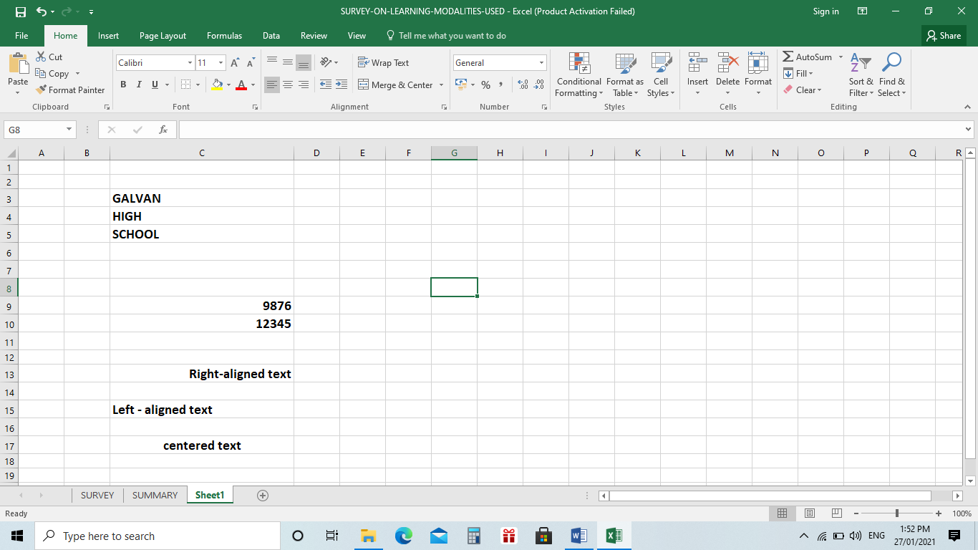

Left-aligned text by default

Right-aligned numbers by default

Alignments

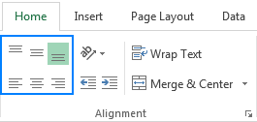

Alignments

**Wrapping Data**

To wrap the data in a cell, select the cell or range of cells then click **Wrap text** button under the **Home** menu in the **Ribbon.**

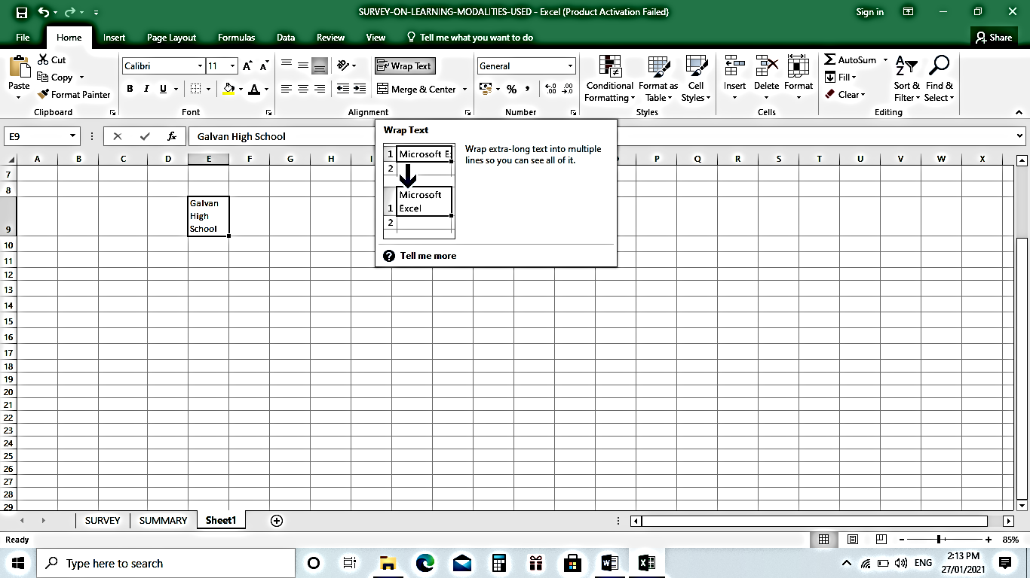

Wrap Text

Wrapped Text

**Merging Cells**

In MS Excel, you have another option of alignment available to you, this is the **Merge and Center.** This is performed when you want to combine more than one cells and merge them into a larger cell. The content will be centered across the new merged cells.

**To merge two cells into one**

1. Select the cells that you want to merge. It can ne cells in a column, row, or both columns and rows.
2. Click the **Merge and Center** button

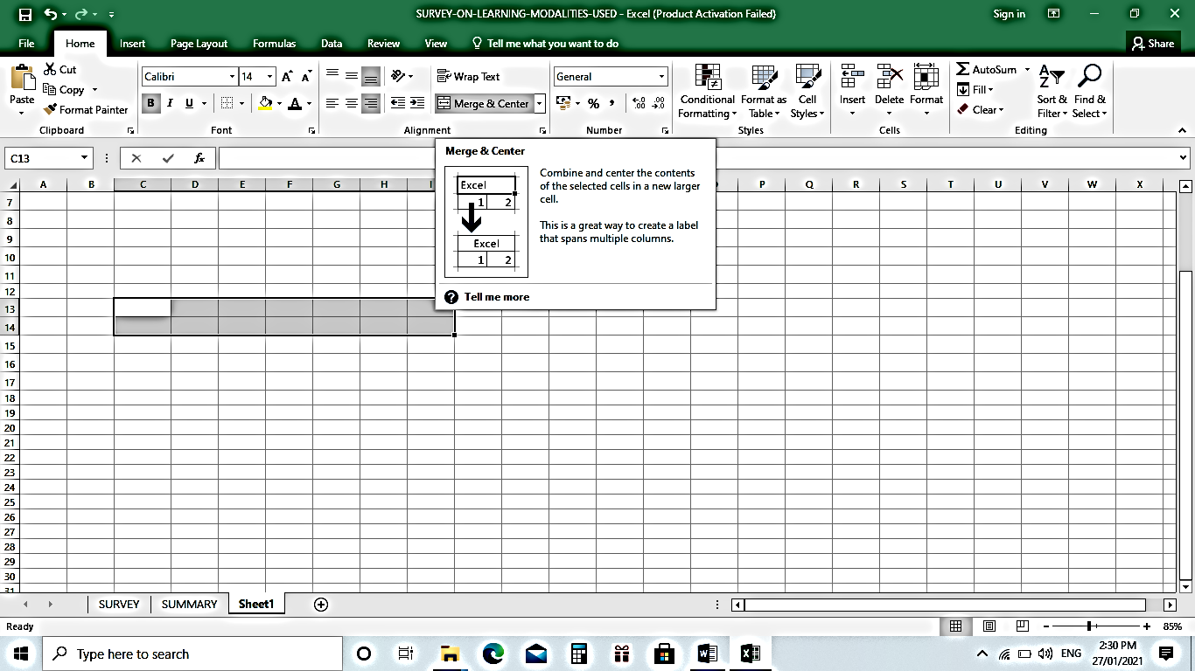

Description

Merge and Center button

Selection

**Copying Cell Formatting**

**To copy cell formatting:**

1. Select the cell with the formatting you want to adopt
2. Select **Home > Format Painter**
3. Drag to select the cell or range of cells you want to apply the formatting to
4. Release the mouse button and formatting should now be applied

*You can also copy cell formatting by*

1. Pointing your mouse at the edge of a selected cell whose format you want to copy
2. Hold down the right mouse button
3. Drag to the cell or range of cell you want to format
4. Release the mouse button
5. Select **Copy here as format only** from the context menu that appears.

**Applying Cell Style**

You can immediately format a cell by selecting a cell style. You can also create your own style or instantly format a range of cells by selecting a table style.

1. 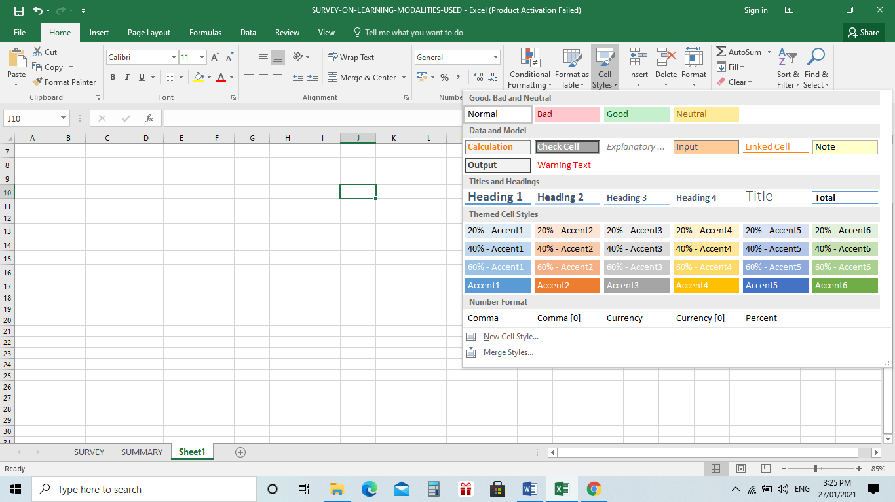For example, select cell J10 below.

Cell Styles

Cell J10

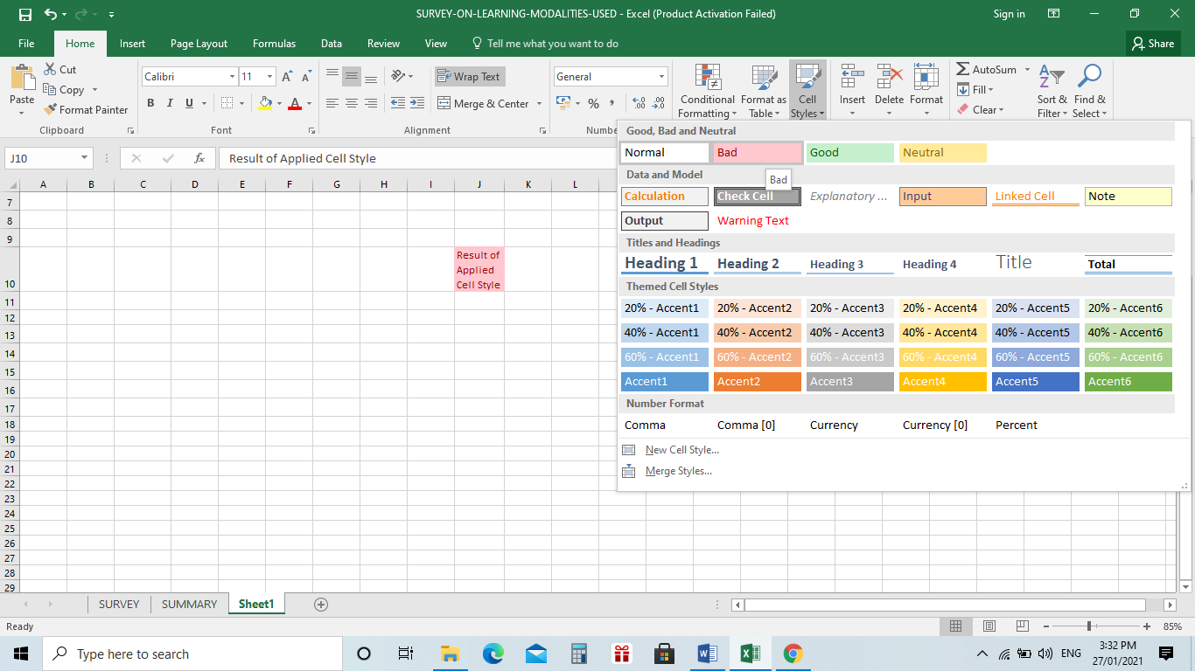

Result of applied cell style

**To create your own cell style, perform the following steps:**

On the **Home** tab in the styles group**,** click the bottom right down arrow. From there, you can find many other cell styles.

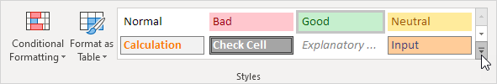

Click New Cell Style.

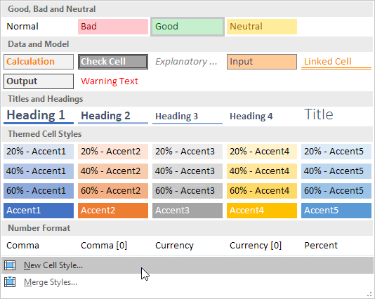

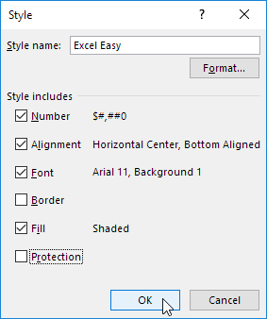Enter a term and click the Format button to define the Number Format, Alignment, Font, Border, Fill and Protection of your own cell style. Uncheck a check box if you don’t want to control a particular type of formatting.

Click OK button

On the Home tab, in the styles group, apply your own cell style

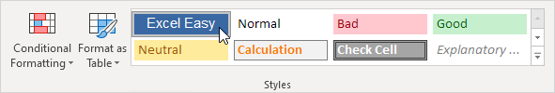

**OUTPUT**

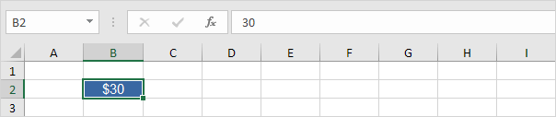

Note: Right click a cell style to change or remove it. Changing a cell style affects all cells in a workbook with that cell style. A cell style is kept in in a workbook where you made it. Open a new workbook and click on Merge Styles (under new Cell Style) to import a cell style.

**LEARNING ACTIVITY SHEET**

**SPECIAL PROGRAM IN ICT 7**

**OFFICE PRODUCTIVITY-MICROSOFT EXCEL**

*Third Quarter, Week 6*

Name of Learner: _____________________________ Date: __________________________

Grade Level /Section: __________________________

**Learning Competency**

1. Format Worksheets

**Exercises/Activities**

1. **SEQUENCING** – Arrange the given steps in formatting a number. 1 as the first step and 9 as the last step. Write number 1-9 on the space provided before the number.

________Click the right button of the mouse then select Format Cells from the shortcut menu

________Click **Use 1000 Separator** box if you want commas (1,000) injected in the number.

________The format cells Dialog box will pop – up

________Use **Negative numbers** drop-down list to indicate how numbers less than zero are to be shown.

________Click **OK** button

________Click **Number** in the category drop-down list.

________Select a cell or range of cells

________Use the decimal places scroll bar to select the number of decimal places to be displayed.

Ex. 2 would show 26.50 and 3 would show 26.500

________Click the Number tab

1. **TRUE or FALSE –** Write **TRUE** if the statement id correct, and **FALSE** if otherwise. Write your answer on the space provided before the number.

**________**1. By default, a Number is left-aligned.

**________**2. Text is aligned to the right by default.

________3. Text and numbers may be aligned using left-align, center and right align buttons

________4. In MS Excel, you have another alignment option available and that is Merge and Center ________5. Use 1000 Separator box allows you to insert commas in large numbers.

________6. Wrap text allows the contents of a cell across several lines be seen in full if the text is larger

than the column width.

________7. The Date can be formatted in many different ways in Excel.

________8. You cannot create your own style or instantly format a range of cells

________9. You can immediately format a cell by selecting a cell style

________10. **Negative numbers** drop-down list indicates how numbers less than zero are to be shown.

1. **EXPLAIN BRIEFLY –** When do we need to format data such as Date, Number, Text, and Timein MS Excel**?** Give specific examples.

**_______________________________________________________________________________________________________________________________________________________________________________________**

1. **HANDS-ON (Optional)**
2. Create a file named My Calendar
3. Apply all the ways to format cells in MS Excel
4. Complete the months of the year and write your important To-Do List
5. Send your output via online to your teacher’s account (e-mail/messenger).

**Activity IV Rubrics**

|  |  |  |  |  |  |
| --- | --- | --- | --- | --- | --- |
| Criteria | 1 | 2 | 3 | 4 | Score |
| Formats Applied | Only 1 – 2 formatting were applied and shown in the output | Only 3 – 4 formatting were applied and shown in the output | Only 5-7 formatting were applied and shown in the output | More than 7 formatting procedures were applied and shown in the output |  |
| Completeness | Only 1 – 3 Months were shown in the calendar output | Only 4 – 6 Months were shown in the calendar output | Only 7 – 10 month were shown in the calendar output | All months are present in the calendar output |  |
| Speed | Activity was accomplished within 5 days and more | Activity was accomplished within 3-4 days | Activity was accomplished within 2 days | Activity was accomplished within 1day and less |  |